GRAMMAR

Comparatives and Superlatives

(Before doing the exercises ,see the link below , you may want to read the lesson on how to form the comparatives and superlatives)

Forming regular comparatives and superlatives
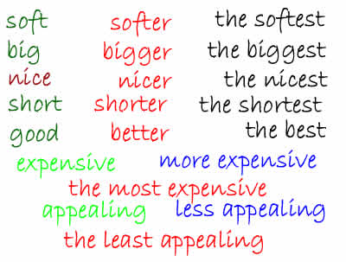
- We use comparatives to compare two things or two people. (e.g She is taller than her husband.)
- Superlatives are used, however, to show the difference between more than two things or more than two people. (e.g Paris is the biggest city in France)
- To form comparatives and superlatives you need to know the number of the syllables in the adjective. Syllables are like "sound beats".
For instance:
- "find" contains one syllable,
- but "finding" contains two — find and ing.

The rules to form comparatives and superlatives:

One syllable adjectives
1. An adjective ending in a silent 'e' — nice
- Comparative — add 'r' — nicer
- Superlative — add 'st' — nicest
2. An adjective ending in one vowel and one consonant — big
- Comparative — the consonant is doubled and 'er' is added —bigger
- Superlative — the consonant is doubled and 'est' is added—biggest
3. An adjective ending in more than one consonant or more than a vowel (or long vowels) — high, cheap, soft.
- Comparative — 'er' is added — higher, cheaper, softer.
- Superlative — 'est is added — highest, cheapest, softest.
Two syllables
4. A two syllable adjective ending in 'y' — happy
- Comparative — 'y' becomes 'i' and 'er' is added — happier
- Superlative — 'y' becomes 'i' and 'est' is added — happiest
Two or more syllables
5. Two syllable (without 'y' at the end) or more syllable adjectives— exciting
- Comparative — more + the adjective + than — more exciting than
- Superlative — more + the adjective + than — the most exciting
Examples
- The Nile River is longer and more famous than the Thames.
- Egypt is much hotter than Sweden.
- Everest is the highest mountain in the world.
- This is one of the most exciting films I have ever seen.
 | 
Peter (6 years old) | Charley (5 months old)
Peter is older than Charley.
Charley is younger than Peter.

Irregular comparatives and superlatives

6. Some adjectives don’t follow the usual rule:
Adjectives | Comparatives | Superlatives
bad | worse | worst
far(distance) | farther | farthest
far(extent) | further | furthest
good | better | best
little | less | least
many | more | most
much | more | most

How to use comparatives and superlatives
Comparatives | Superlatives
●Comparatives are used to compare two things or two people:  Alan is taller than John. | ●Superlatives are used to compare more than two things or two people. Superlative sentences usually use 'the':  Alan is the most intelligent.

Similarities

To express similarities use the following structure:
... as + adjective + as ...
Examples:
- Mike is as intelligent as Nancy.
- Larry is as popular as Oprah.
EXERCISES
Do the exercises which appear on this website:
https://www.myenglishpages.com/site_php_files/grammar-exercise-grammar-comparatives-superlatives.php

