Describing Products: adjectives
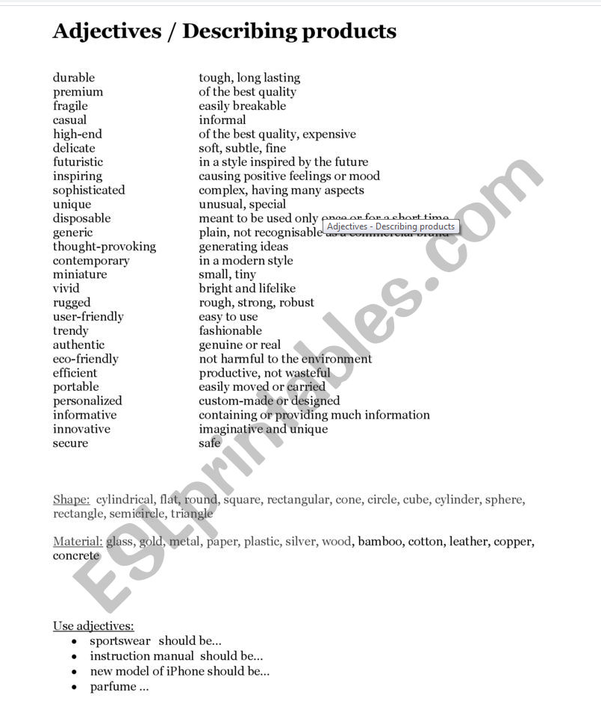
TAKE NOTE: For further practice, have a look at this website to see a large list of adjectives with their corresponding exercises:
http://www.englishvocabularyexercises.com/general-vocabulary/

