Describing products
This is an activity for business/general English students. The objective is to develop vocabulary related to describing products. They will practice adjectives, opposites and compound adjectives. Level:intermediate
Look at these products. Which adjectives would use to describe them?
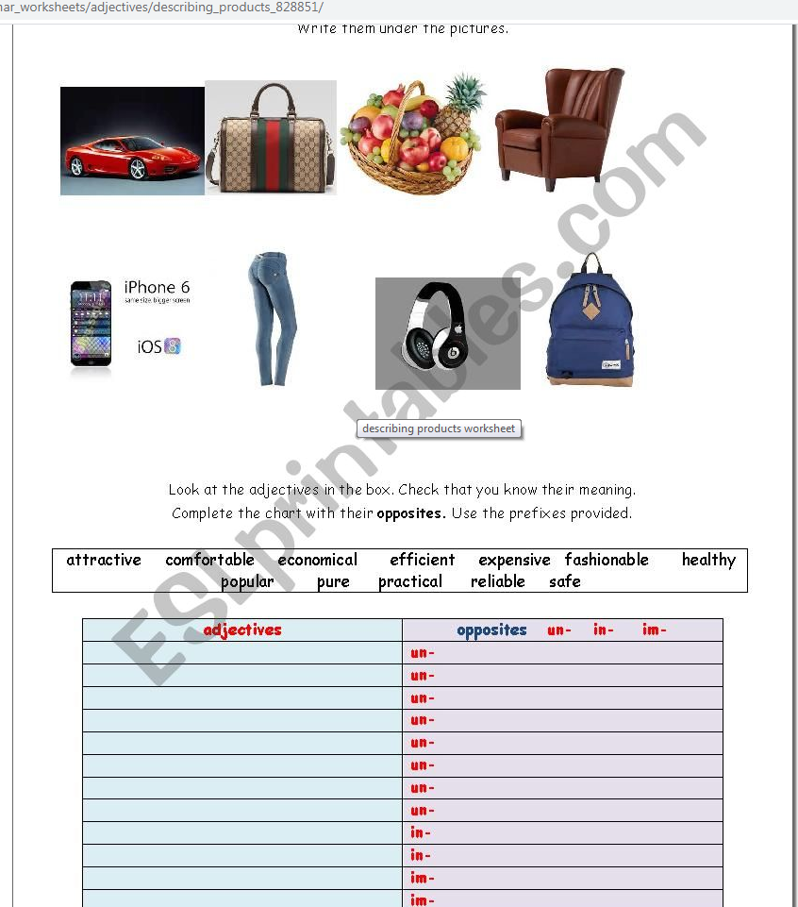

When we describe products , we often use compound nouns.
