**Explaining an electrical circuit**

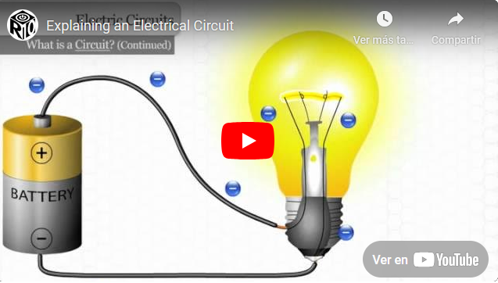

**Watch the video and fill in the gaps with the following words:**

|  |
| --- |
| **shortcut closed Simple light up allow path insulators complete work negative filament heat** |

A __________________ circuit allows a light bulb to __________________ by providing a __________________ for electrical current to flow.

Electrons move from the __________________ side of a battery to the bulb, passing through a __________________ that converts electrical energy into __________________ and light.

For the bulb to light, there must be a __________________ circuit, meaning the electrons must return to the positive side of the battery.

This unbroken path is called a __________________ circuit, which is essential for electricity to flow.

__________________ are materials that prevent electron flow, while conductors __________________ it.

If a circuit is interrupted or if electrons take a __________________, it leads to a short circuit, which can cause problems.

Understanding these concepts is important for grasping how electrical circuits __________________.