The electric circuit: review 1

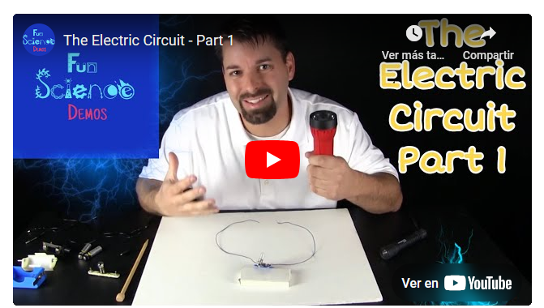

Jared shows how electricity makes a light bulb _______________(1).

Electricity moves in a path called _______________(2).

It starts from _______________(3), goes through _______________(4), and into _______________(5).

Inside the light bulb, electricity travels through _______________(6).

Then, it goes back to _______________(7), completing _______________(8).

This is how _______________(9) too.

Remember, electricity always moves _______________(10)!