

**PAST SIMPLE – regular/ irregular verbs**

**Nikola Tesla** (1856-1943) Croatian Inventor

Nikola Tesla ___________ (be) born on **10th July 1856** in **Smiljan**, small village in **Croatia** (then part of the Austro-Hungarian Empire). His father ___________ (be) a Serbian Orthodox priest and his mother ___________ (take) care of the family’s farm. Nikola ___________ (say) that he ___________ (must) to thank her for his creative abilities and near photographic memory - he ___________ (can) memorize entire books and recite them at will. Tesla ___________ (speak) **eight languages**: Serbian, Latin, German, Hungarian, Italian, Czech, French and English.

He ___________ (use) to say ''I'm proud of my Serbian origin and my Croatian homeland''.

When Tesla’s brother Daniel ___________ (die) in an accident, it ___________ (be) a shock to the 7-year-old Nikola. He then ___________ (start) to have **visions**, important also in his later life.

Tesla ___________ (go) to the gymnasium in Carlstadt (Karlovac, Croatia). When performing calculus equations in his head his teachers ___________ (think) he ___________ (be) cheating. He ___________ (love) mathematics and science. Tesla’s father, however insisted that he enter the priesthood. After his recovery from cholera father ___________ (send) him to the Polytechnic school in Graz, Austria in 1875. He ___________ (be) excellent there. He ___________ (begin) each day at 3:00 a.m. and ___________ (work) until 11:00 p.m..

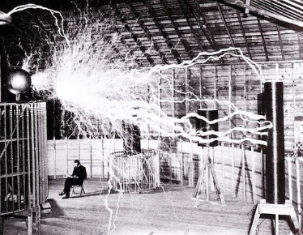In school Tesla ___________ (be) obsessed with a new **direct current** (**DC**) dynamo as he ___________ (know) better solution: electric power created by **alternating current** (**AC**).

At the age of 28, working for Edison, he ___________ (move) from France to New York City with only four cents in his pocket. One day Tesla ___________ (tell) Edison that he ___________ (can) improve his motors and generators. Edison ___________ (promise) him 50.000 dollars. After several months Tesla ___________ (improve) the motor but when he ___________ (ask) about payment, Edison ___________ (tell) him that he ___________ (be) only joking. Tesla immediately ___________ (resign).

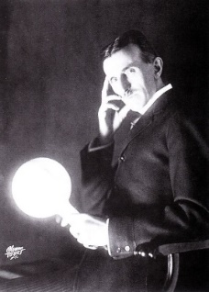Later he ___________ (found) the *Tesla Electric Company* and ___________ (patent) his AC motors.

After many years of debate in so called **'War of the Currents'** Tesla __________________ (demonstrate) at ***1893*** ***World Fair in Chicago,*** the safety of AC power with his new **phosphorescent lighting** and his gigantic **'Tesla coils'**. It __________ (be) a key event in the history of electricity.

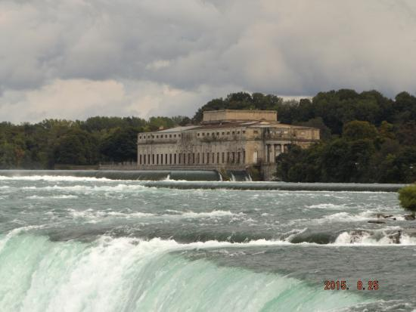Tesla and Westinghouse with the *General Electric* company ______________ (create) **the first modern power station** at **Niagara** **Falls**.

Tesla also ___________ (make) important research in radiant energy (later called **X-ray**), and on the fundamentals of **radio**.

Tesla ___________ (have) an eccentric private life. He never ___________ (sleep) for more than two hours at a time. He ___________ (live) alone in a hotel suite. He also ___________ (have) several obsessions: a phobia of germs (when meeting people, he __________________ (not want) to shake hands), round objects (especially jewelry), the number three and also feeding pigeons... Tesla ___________ (say) this behavior ___________ (make) his concentration on the experiments better.

On 7th January 1943, at the age of 86, Nikola Tesla ___________ (die) in New York a poor and reclusive man. He ___________ (had) 700 patents. His legacy, however, continues to move on.