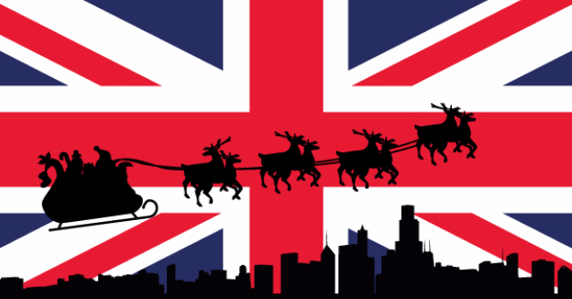

Christmas and New Year in Britain

True or false
Boxing Day is on the 25th of December
People visit their friends on boxing Day and make cookies
Christmas Day is on 25th of December
People sing nursery rhymes at Christmas
In Britain Children leave mince pie for Santa
They eat turkey and pudding for Christmas dinner
Inside the cracker there is a candy cane.
Boxing Day is the day after Christmas.
In London many people celebrate New Year’s Eve in Trafalgar Square.
The big Christmas tree in Trafalgar Square is a present from America.

Listen and tick the sentences you hear
Christmas Eve is on the 24th of December.
Christmas day is on 25th of December.
The day before Christmas is Christmas Eve.
Boxing Day is the day before Christmas.
People visit their relatives and friends and give them presents.
You can hear music from different places.
People listen to songs called carols in the streets at Christmas time
In Britain Children leave mince pie for Santa clause on Christmas Eve.
It is a very busy time for families in England.
They prepare gifts, make Christmas cake, hang stockings near the fireplace.
Children often write letters to Father Christmas or Santa with their wishes.
Families usually have turkey or goose with vegetables.
They eat roast turkey and Christmas pudding for their traditional Christmas dinner.
In London many people celebrate New Year’s Eve in Trafalgar Square.

Answer the questions
When is Christmas Eve?
When is Boxing Day?
What did people give to poor people on Boxing Day?
What do people sing at Christmas?
What do children leave for Santa?
What do people often eat at Christmas?
Where do many people celebrate the New Year’s Eve in London?
Which country provides Britain with a Christmas tree for Trafalgar square?

Boxing Day is on the 25th of December
People visit their friends on boxing Day and make cookies
Christmas day is on 25th of December
People sing nursery rhymes at Christmas
In Britain Children leave mince pie for Santa
They eat turkey and pudding for Christmas dinner
Inside the cracker there is a candy cane.
Boxing Day is the day after Christmas.
In London many people celebrate New Year’s Eve in Trafalgar Square.
The big Christmas tree in Trafalgar Square is a present from America.

Listen and tick the sentences you hear.
Christmas Eve is on the 24th of December.
Christmas day is on 25th of December.
The day before Christmas is Christmas Eve.
Boxing Day is the day before Christmas.
People visit their relatives and friends and give them presents.
You can hear music from different places.
People listen to songs called carols in the streets at Christmas time
In Britain Children leave mince pie for Santa clause on Christmas Eve.
It is a very busy time for families in England.
They prepare gifts, make Christmas cake, hang stockings near the fireplace.
Children often write letters to Father Christmas or Santa with their wishes.
Families usually have turkey or goose with vegetables.
They eat roast turkey and Christmas pudding for their traditional Christmas dinner.
In London many people celebrate New Year’s Eve in Trafalgar Square.

